All the information you need to know about activating a Fiori app is in [Fiori Apps Library](https://fioriappslibrary.hana.ondemand.com/sap/fix/externalViewer/) Actually it is not just about activating, you can find the all the information of a Fiori app like installation, configuration, roles, catalog&group descriptions, extension points, related apps, etc..I strongly recommend you to be familiar with it.

As an example I will activate [People Profile](https://fioriappslibrary.hana.ondemand.com/sap/fix/externalViewer/#/detail/Apps('F1382')/W17) app.. Since I just have an IDES system, I will not be able to activate an S4/HANA app.But the steps are completely the same..

First of all you have to be sure that you can use the fiori app on your system.As seen below, People Profile is a SAP Business Suite app and it can run on Any DB.

[metin içeren bir resim

Açıklama otomatik olarak oluşturuldu](http://zyndanismanlik.com/wp-content/uploads/2019/10/1.png)

Then, go to Impelementation Information tab and Installation section and check if the necessary components are installed on your system.

[metin içeren bir resim

Açıklama otomatik olarak oluşturuldu](http://zyndanismanlik.com/wp-content/uploads/2019/10/2.png)

You have to check both your gateway and ERP systems.In my case(IDES), they are the same.In order to check, I use System->Status and click Components button..

[tablo içeren bir resim

Açıklama otomatik olarak oluşturuldu](http://zyndanismanlik.com/wp-content/uploads/2019/10/3-1.png)

and confirm that you have the components with correct release and SP-levels..

[metin içeren bir resim

Açıklama otomatik olarak oluşturuldu](http://zyndanismanlik.com/wp-content/uploads/2019/10/4.png)

If everything is OK, then go to Configuration section..You have to activate the BSP app and related OData service.

[metin içeren bir resim

Açıklama otomatik olarak oluşturuldu](http://zyndanismanlik.com/wp-content/uploads/2019/10/5.png)

Activating the BSP is straightforward.Just go to SICF in your gateway system and activate the services..

[metin içeren bir resim

Açıklama otomatik olarak oluşturuldu](http://zyndanismanlik.com/wp-content/uploads/2019/10/6.png)[metin içeren bir resim

Açıklama otomatik olarak oluşturuldu](http://zyndanismanlik.com/wp-content/uploads/2019/10/10.png)

In order to activate the OData service, you need to register the service to your gateway system via the transaction /IWFND/MAINT_SERVICE and Add Service button..

[metin içeren bir resim

Açıklama otomatik olarak oluşturuldu](http://zyndanismanlik.com/wp-content/uploads/2019/10/7.png)

Select a package and request for your service.. And now your OData service is active too..

[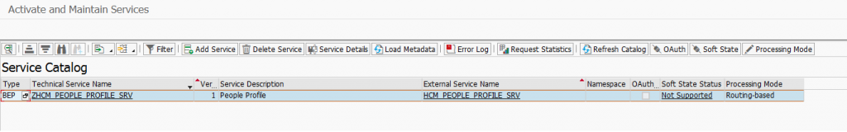](http://zyndanismanlik.com/wp-content/uploads/2019/10/8.png)

As the last step, you have to give role to users for the app to be visible in FLP.. Add the role SAP_HR_BCR_EMPLOYEE_T (Configuration section in Fiori Apps Library) to the users..

Since there are other apps in the catalog, we see lots of new apps on our launchpad..If you want to activate the other apps, you can follow the above steps..If you don’t, you have to create new catalog and group and assign them to a new role.But it is the topic of another article

[tablo içeren bir resim

Açıklama otomatik olarak oluşturuldu](http://zyndanismanlik.com/wp-content/uploads/2019/10/12.png)

Check the People Profile app and voila!!

[metin içeren bir resim

Açıklama otomatik olarak oluşturuldu](http://zyndanismanlik.com/wp-content/uploads/2019/10/11.png)